Pacific Capability GUI

User Manual

Chris Remington

November 2, 2012

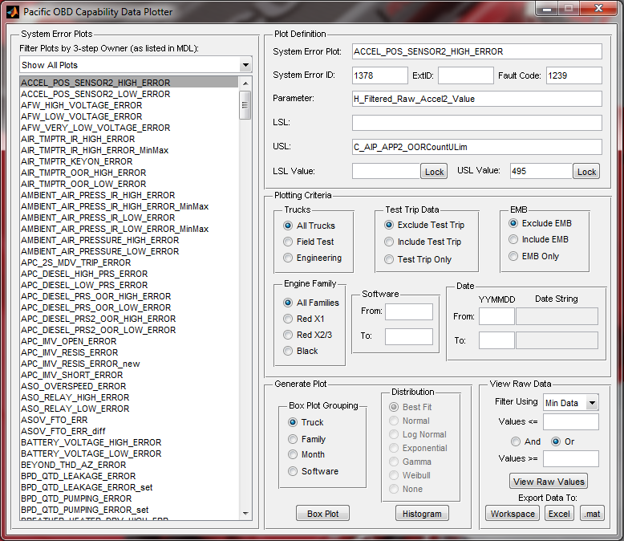

**Introduction**

The Capability GUI is designed to allow 3-step owners to more quickly generate their own capability data plots using the Min/Max or Event Driven OBD capability data. The main benefits include:

* Access to the latest truck data sets (no waiting for the automated process to be run)
* Increased ability to filter data and generate plots on demand
* Better ability to investigate trends without having to dig through the network for the required plot
* Vastly improved methods to view the raw data comprising a plot to isolate failures
* Improved ability to export the raw capability data to other formats to use as desired

**GUI Window Overview**

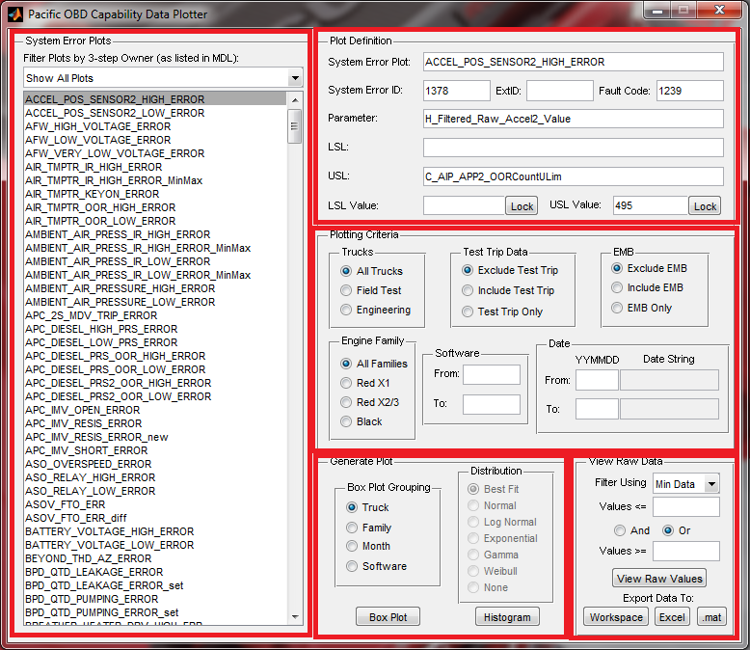

Filter Criteria

Generate Plots

Data Export

Plot Definition

Plot Selection

**Plot Selection**

This allows you to select the system error plot that you would like to generate. For system errors with more than one plot, there will be a listing here for each plot that will be named slight differently from the others to differentiate it. The names presented in this are analogous to the folder names present in the **BoxPlots** and **Histograms** folder in the Pacific capability folder.

**Plot Definition**

This section will contain the information pertaining to the definition of the plot. This includes the system error id, the system error name (plot name), the fault code, the parameter plotted, the LSL and/or USL, and the LSL and/or USL value(s).

**Filter Criteria**

This section contains selections to allow the user to control how the data used to generate the plot will be filtered. Each selection is independent of the others. Possible data filtering abilities include type of truck, engine family, whether the data was taken on a test trip, engineering monkey business status of the data, software version of the ECM, and the data the data was taken.

**Generate Plots**

This section is where you can generate a box plot or a histogram. Box plots can be grouped by truck name, engine family, month, or software version. Histograms can be generated with a normal, log-normal, exponential, gamma, or weibull distribution. Alternatively, the user can select no distribution to see just a histogram or select best fit and the tool will attempt to estimate the best distribution to fit to the data.

**Export Data**

This section allows for the user to export or view the raw data used to generate the plot. The additional filtering allows by data value can be used to isolate the data exported to only values past the threshold values so failure data is more easily identified.

**Getting Started**

From the starting pane of the CapabilityGUI, the first task is to select the system error that you want to generate a plot of. A list of 3-step owners is present in the drop-down menu above the plots. By default, plots are shown for all 3-step owners. You can select your name in this box to view only plots of system errors that are owned by you in the Master Diagnostic List.

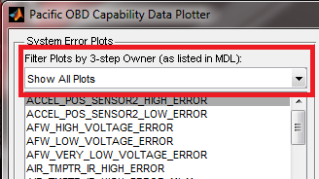

The next step is to select the system error and plot that you want. If a single system error has multiple plots (i.e., multiple event driven parameters, event driven plot and min/max plot, etc.) it will appear multiple times with slightly different names. Additional plot definitions may also be created when the tuning of a diagnostic changes between software revisions. Here is an example of **NOX_OUT_SENS_IR_STUCK_ERR** selected.

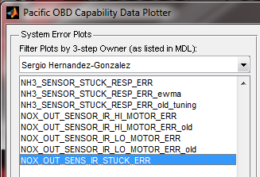

Once a plot is selected, its information will be populated in to the **Plot Definition** section of the GUI. You can use this to verify that the correct parameter and threshold are being used. The threshold values are pulled from the latest mainline calibration and should represent the latest tuning of the values.

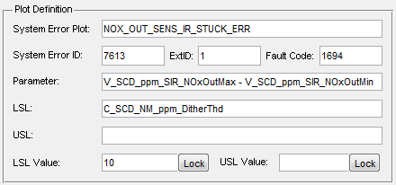

Once the plot is selected and its information is verified, the next step is to select the desired filtering criteria for the plot to be generated. Each selection is independent of each other. In this example, only data from Pacific Black field test truck with 7.10.0.5 and newer software will be plotted. Test trip and EMB data will also be excluded from the plot.

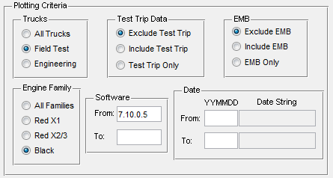

Now that the data set has been selected, plots can be generated or the raw data can be exported. Let’s start with making a box plot. There are four different selections for how to group the data. Select the option that best matches your need and press **Box Plot**.

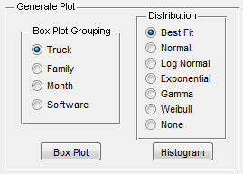

Each plot will be generated in a new figure window. The following is an example of a box plot generated with the conditions specified earlier. Since this is a standard Matlab figure, you can view, save, and export it like any other plot you would make. The box plot generated in the same style as the capability plots present on the network, please see the documentation in **DL_Diag\2013 OBD Capability Analysis\Pacific\Training** for a description of how the read the plot and what data it contains.

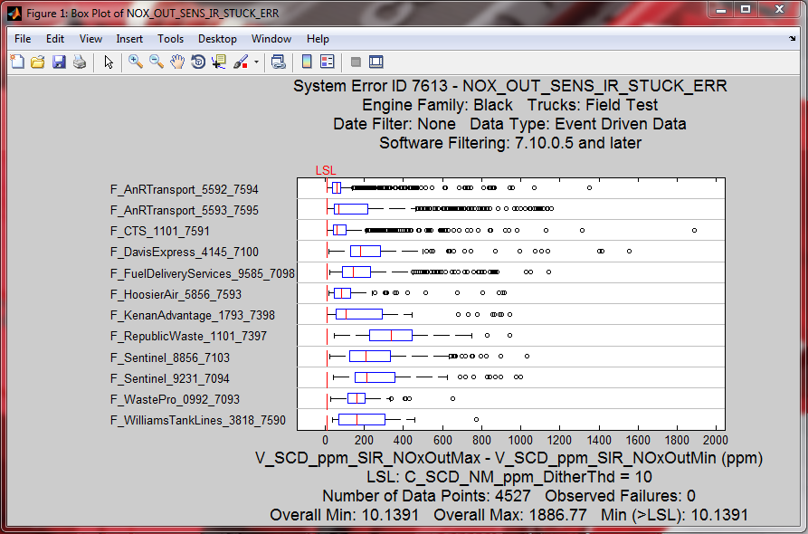

If you desire to generate a histogram, you can select the desired distribution and click **Histogram**. The following in an example generated using the filtering conditions set earlier with the **Best Fit** histogram selected. When **Best Fit** is selected, the tool will attempt to fit all five distributions (if they can be fit to the data set) and will select the best fit. The distribution selected will be indicated on the plot. These histograms are very similar to the plots on the network drive, please see the documentation in **DL_Diag\2013 OBD Capability Analysis\Pacific\Training** for a description of how the read the plot and what data it contains.

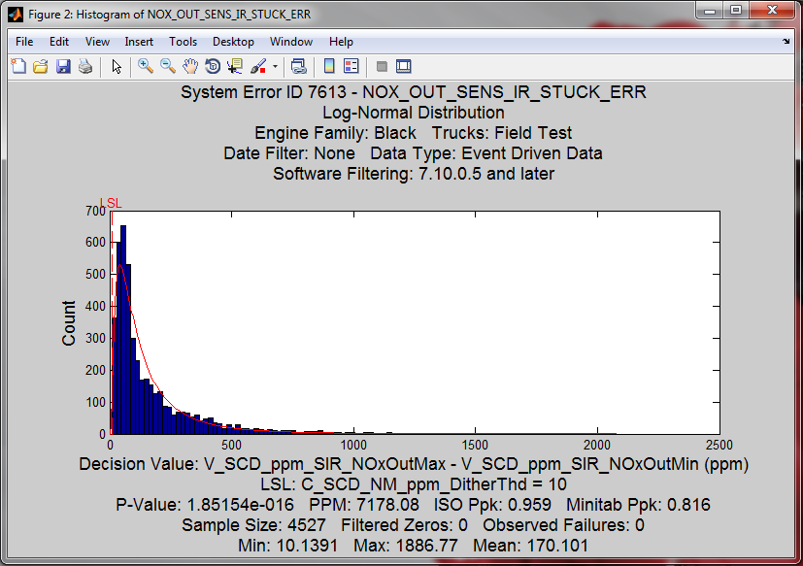

Further, the data set that was plotted here can be exported to many different formats to allow for additional study; for example, in Minitab. This can be done in the **View Raw Data** section of the tool. There are four primary methods that raw data can be exported: view data set in a Matlab GUI window, push data to the workspace, generate an Excel file of the data, or generate a .mat file of the data. Any filtering conditions specified in the **Plotting Criteria** section will also be applied to the raw data export so that the base data upon which the plot and data export is made will be identical.

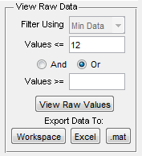

Let’s start by viewing the data in a Matlab GUI window. This allows you to quickly look at a spreadsheet view of data points with minimal effort. **WARNING:** This GUI window can become slow and unresponsive when > 1,000 values are entered into it. It is recommended to use the additional data value filter to reduce the data set size to only the extreme values of interest. In the example above, the filter is set to **<= 12** so that only parameters less than or equal to 12 will be exported to the GUI window. Click the **View Raw Values** button to open the data in a viewable window. Below is an example of the window that will open. Here you can easily find outlier data points, the date and time they occurred, what truck they came from, etc.

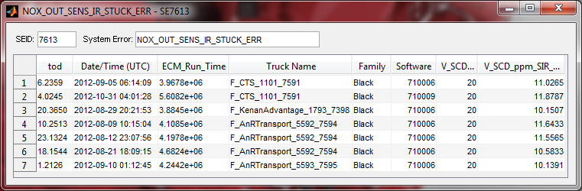

The other three options to export the raw data are more powerful. If you clear out the value filter of 12 specified earlier and then press **Workspace**, this will export the entire raw data set used to generate the plots into the workspace. You can see the results of that below where each value plotted has now been exported into the workspace.

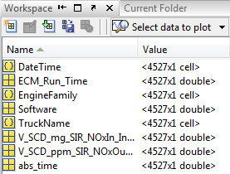

If you had instead pressed the **.mat** button, you would have been prompted to enter a file name and those variables would have been saved into the specified file.

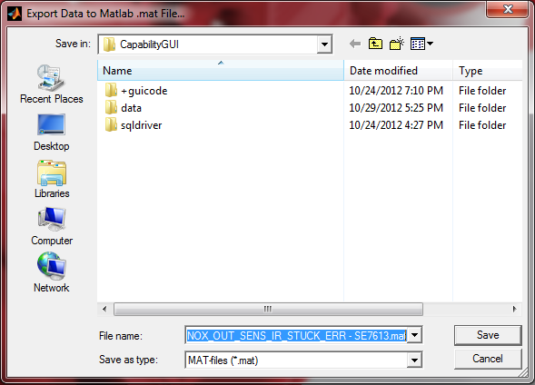

The last data export option is to export the data to an Excel spreadsheet. If you click the **Excel** button in the **View Raw Data** sections, you will be prompted to enter a file name similar to the above for exporting to a .mat file. Once you click save, an Excel file will be generated containing the data. This is an example of a file generated using the previously specified settings.

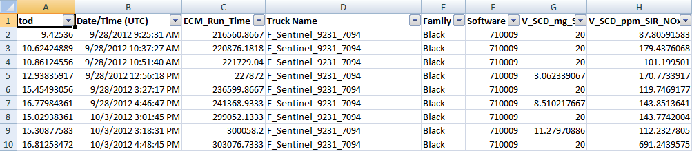

That concludes the basic overview of how to use the **CapabilityGUI** tool.

**Other Features**

**Histogram Distribution Selection**

When a system error has Min/Max capability data, the selection of a distribution during histogram creation will be disabled. This is due to the fact that Min/Max data does not capture each unique diagnostic decision, but instead only gives the most extreme values over a key-switch cycle. For this reason, a traditional distribution has little meaning on Min/Max data.

When selecting a distribution for a histogram composed of event driven data, please also consider the following points:

* If **None** is selected for the distribution, data points equal to 0 are kept in the histogram
* For all other distributions, values equal to 0 are trimmed as most distributions cannot accept values of 0 as inputs
* If the diagnostic has data that is negative and positive, only the **Normal** distribution selection will complete successfully; all other distributions don’t accept negative values
* For diagnostics with a LSL, the exponential distribution will give an error
* When **Best Fit** is selected for the distribution, any combinations mentioned above that are not valid won’t be considered (i.e., when a diagnostic has positive and negative data, only the Normal distribution will be selected as this is the only possible choice)
* If a diagnostic has data that is composed entirely of negative values, all the data will be flipped along with the thresholds to be positive before a distribution is fitted. This won’t happen if **None** is selected for the distribution type.

**Engine Family Specific Thresholds**

In some cases, the threshold parameter will have different values across different engine families. In that case, when the **All Families** radio box is selected in the **Engine Family** grouping of **Plotting Criteria**, the **CapabilityGUI** will default to using the threshold value from the **Red X1** calibration. Selecting either **Red X2/3** or **Black** will update the values of the LSL and/or USL to their correct values for the selected engine family.

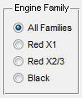

**Manually Specified LSL and USL**

When generating plots, you also have the option to specify a LSL or USL value other than the one that automatically populates the **LSL Value** or **USL Value** fields. This can be helpful when considering the effect of changing a threshold value or when the mainline calibration hasn’t had a required overlay applied yet. If you change the LSL or USL values, the **Lock** button next to value will become selected. This keeps the value entered from being automatically updated if the engine family selection is changed (as detailed above).

When a manually specified threshold value is used, the parameter name indicated in the plot for either the LSL or USL will change from the Calterm parameter name to **User_Specified_Value**. This is to indicate that the value represented on the plot is not the same as the value of the parameter in the current mainline calibration.

**System Error Plots**

Each entry in the **System Error Plots** list box correlates to a plot folder on the capability network share. In an attempt to maintain some resemblance of unity between what is present on the network (generated by the automated process) and what this tool will generate, the plots listed here will be defined in one central location and can’t be modified or added to by the tool user. If you have a desire for a new plot, please contact the current person in charge of OBD capability and work with them to define a new plot or correct an existing plot. This will ensure that the automated process is generating the correct plots in addition to the **CapabilityGUI** tool.

**Raw Value Filtering for Min/Max Data**

Since the Min/Max data will always have two values associated with each point in time (a min and a max), you will need to select whether or not to filter the raw data values on the Min Data or Max Data. This selection can only be made for diagnostics with Min/Max capability data; otherwise it will be grayed out for diagnostics with event driven data.

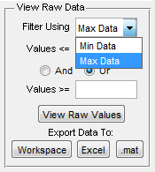

Be mindful of this selection when attempting to use the values filter on Min/Max data. When plotting, Max data will be plotted for diagnostics with an USL only and Min data will be plotted for diagnostics with a LSL only. For diagnostics with both a LSL and USL, Min and Max data will be plotted. This will be noted next to the **Data Type:** field on a box plot or histogram.

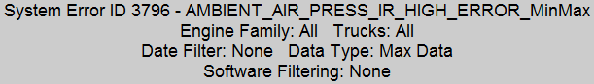

When selecting the various system error plots, the **Min Data** and **Max Data** selection will change automatically depending on if there is a LSL or USL to help reduce confusion with this selection so that it will likely never need to be changed by the user.

**Sorting With the View Raw Values Window**

The raw data window that opens after pressing **View Raw Values** allows for single and multi-level sorting of the data. A single mouse click on any column will activate single level sorting, indicated by the 1 and arrow (as demonstrated below) at the top of the column. Continued clicks will toggle between ascending, descending, and no order.

**WARNING:** Numeric columns are sorted as text so they may not be in the expected order.

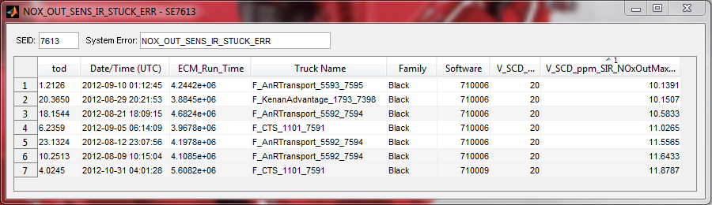

In order to activate additional levels of sorting, you will need to hold down the Ctrl key and select the additional columns that sorting is desired on, where additional clicks on the same column will toggle between ascending, descending, and no order. You can sort on as many columns as you’d like. Here is an example of sorting on Truck Name as the first level and the parameter value on the second level, both in ascending order.

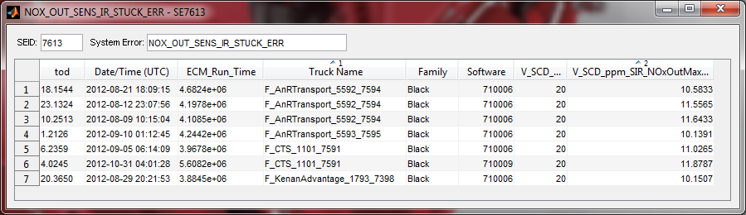

**NOTE:** If you are analyzing a large amount of data and want more control over additional filtering and sorting, it is recommended that you export the sample data set into an Excel spreadsheet. The tool generates Excel spreadsheet with a filter column already applied. Excel is much faster and more powerful when doing more in-depth operations. This raw data window in this tool was only intended as a quick way to view a selected few values without the hassle of using Excel or opening the variable editor in Matlab.